**DAILY ONLINE ACTIVITIES SUMMARY**

|  |  |  |  |  |  |  |  |
| --- | --- | --- | --- | --- | --- | --- | --- |
| **Date:** | **04-05-2020** | | | | **Name:** | **B.A.SOHANKUMAR** | |
| **Sem & Sec** | **4th SEM A** | | | | **USN:** | **4AL18CS013** | |
| **Online Test Summary** | | | | | | | |
| **Subject** | | **MICROCONTROLLER AND EMBEDDED SYSTEMS** | | | | | |
| **Max. Marks** | | **20** | | **Score** | | **14** | |
| **Certification Course Summary** | | | | | | | |
| **Course** | **INTRODUCTION TO CYBER SECURITY** | | | | | | |
| **Certificate Provider** | | | **GREAT LEARNING ACADEMY** | **Duration** | | | **7 HOURS** |
| **Coding Challenges** | | | | | | | |
| **1:Write a c++ program to find missing number in array.**  **2:Write a java program to read three integer values from the keyboard and find the sum of values.** | | | | | | | |
| **Status: EXECUTED** | | | | | | | |
| **Uploaded the report in Github** | | | | **YES** | | | |
| **If yes Repository name** | | | | **LOCKDOWN CODING** | | | |
| **Uploaded the report in slack** | | | | **YES** | | | |

**ONLINE TEST DETAILS:**

Today test was on MICROCONTROLLER AND EMBEDDED SYSTEMS (18CS45) on module 3.The duration of the test was 30 minutes from 02.00pm to 02.30pm.There were 20 multiple choice questions.Score I received is 14/20.



**CERTIFICATION COURSE DETAILS:**

Course: INTRODUCTION TO CYBER SECURITY

I have successfully completed the above course.In today's certification course i have completed with the topics Introduction to Cryptography,Secure System Design,Threats and Vulnerabilities,What Is Cybersecurity.And completed assessment quiz.



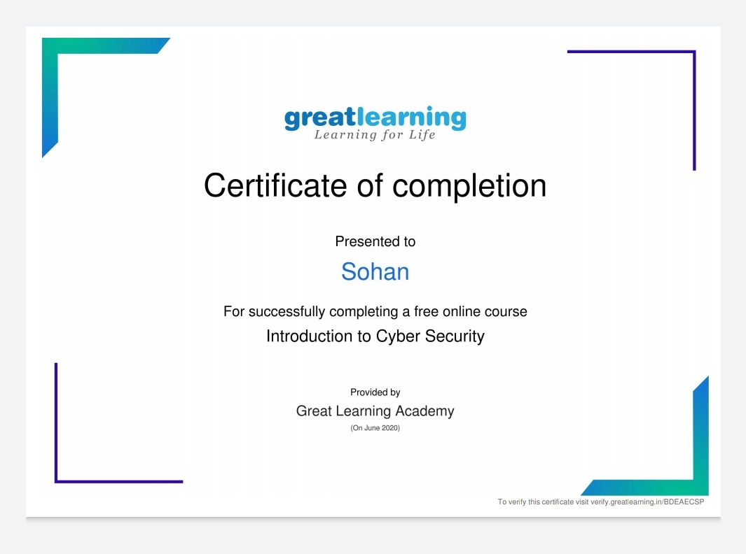

**Above certificate is issued for the completion of course.**

**CODING CHALLENGES DETAILS:**

1.Write a c++ program to find the missing numbers in array.Given an array C of size N-1 and given that there are numbers from 1 to N with one element missing, the missing number is to be found.

Input:The first line of input contains an integer T denoting the number of test cases. For each test case first line contains N(size of array). The subsequent line contains N-1 array elements.

Output:Print the missing number in array.

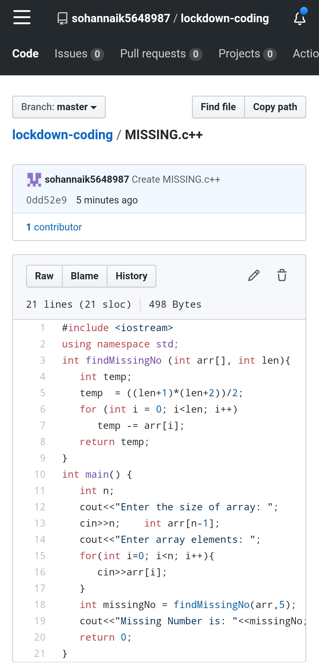

2.Write a java program to read three integer values from the keyboard and find the sum of the values. Declare a variable "sum" of type int and store the result in it.

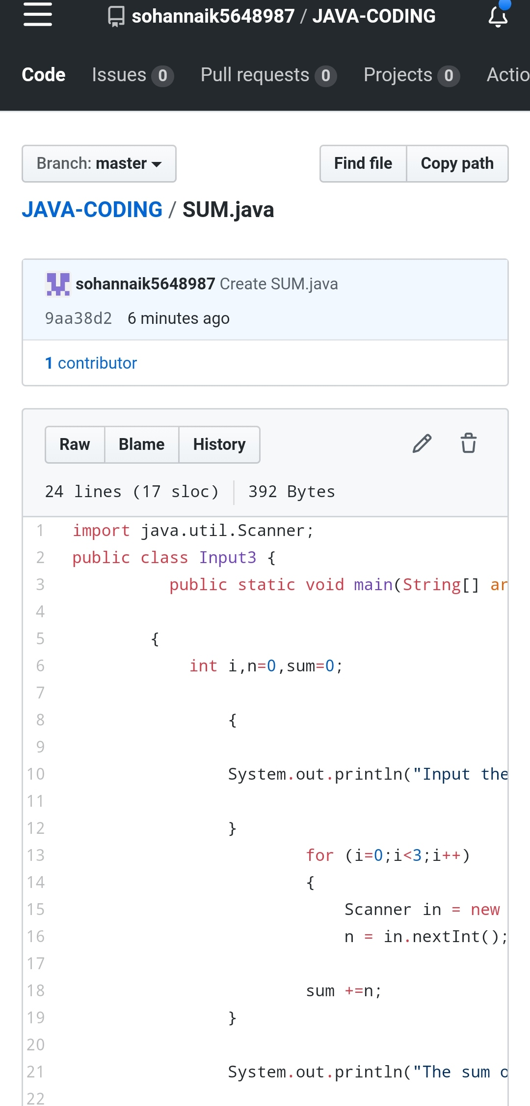

REPOSITORY LINK: https://github.com/sohannaik5648987/lockdown-coding

https://github.com/sohannaik5648987/JAVA-CODING